LAB 3: Vlookup Lab

Given tables:

Worksheet 1: Products

|  |  |  |
| --- | --- | --- |
| Product ID | Product | Price |
| 101 | Product A | 120 |
| 102 | Product B | 150 |
| 103 | Product C | 200 |
| 104 | Product D | 90 |
| 105 | Product E | 220 |
| 106 | Product F | 130 |

Worksheet 2: Orders

|  |  |  |
| --- | --- | --- |
| Order ID | Product ID | Quantity |
| 1 | 101 | 2 |
| 2 | 103 | 1 |
| 3 | 105 | 4 |
| 4 | 106 | 3 |
| 5 | 102 | 5 |
| 6 | 104 | 6 |

1. Use VLOOKUP to find the product names for each Product ID in the Orders worksheet.

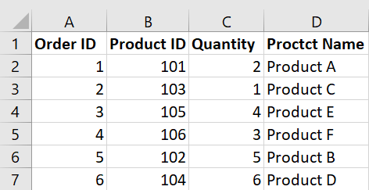

2. Use VLOOKUP to find the price for each Product ID in the Orders worksheet, then calculate the Total Price by multiplying the Quantity by the Product Price.

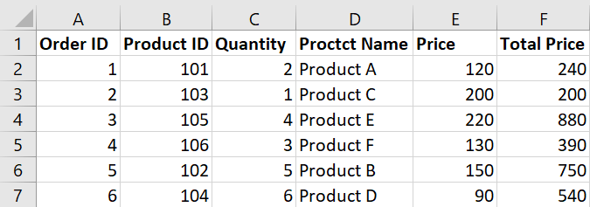

3. Use VLOOKUP to check if there are any Product IDs in the Orders worksheet that do not exist in the Products worksheet.

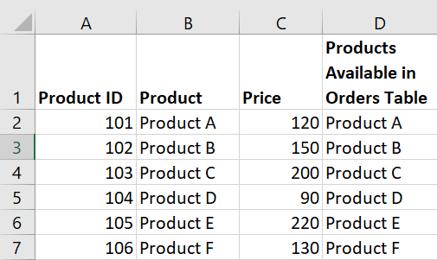

4. Assume a discount of 10% is given on all products. Use VLOOKUP to find the original price and then calculate the discounted price.

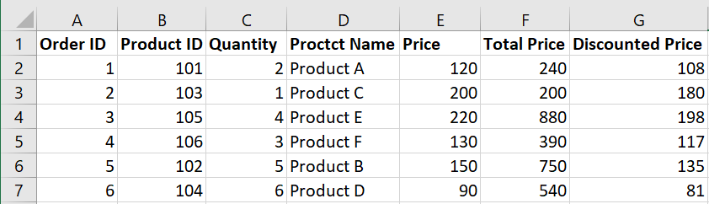

5. Use VLOOKUP to find the price for each Product ID and then calculate the order value. Find the maximum order value from the list.

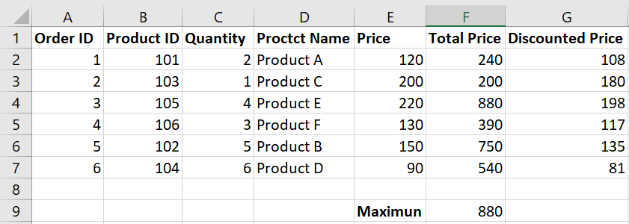

6. Use VLOOKUP to find out which products from the Products worksheet have not been ordered.

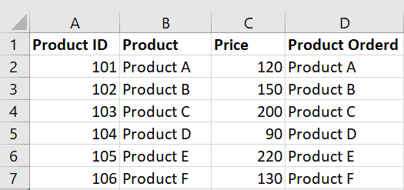

7. Use VLOOKUP to find the Product name and summarize the total quantity sold for each product.

